Ryan Benac

Bedrock & Surficial Map Project, SW Montana

February 2, 2021

Introduction

This report focuses on the bedrock and surficial mapping for the geology of southwestern Montana. The bedrock map is in Frying Pan Gulch and the surficial map focuses on the Hebgen Lake region. The amp figures mentioned can be found at the end of the report where Figure 1 is the Frying Pan Gulch Bedrock Map and Figure 2 is the Hebgen Lake Surficial Map. The overall objective for this project was to learn and practice identifying common geologic features using only remote sensed data. Specific geologic features include unit contacts, faults, folds, and evidence for landslides, alluvial fans, and glacial activity. This objective leads to the main goal of mapping the bedrock and surficial geology in each respective region using only remote sensed data. The approach to achieving the objective was to learn characteristics of contacts between geologic units as well as common indicators of surficial geologic features. After there is information for how to identify these features, then a satellite image can be used to begin mapping each area.

Methodology

GIS allowed the addition of a variety of map layers to present different forms of data. For the bedrock map, the satellite map and a contour line layer were added. The satellite map shows an aerial view of the ground. The contour line layer was added to see lines of equal elevation throughout the map. This helped to define the topography and see where the hills and valleys were throughout the map area. In addition to the satellite map, there was many other GIS data available for the surficial map at Hebgen lake. The Digital Elevation Map(DEM) presented elevation differences as color contrast on the map. The hillshade and aspect data showed areas of equal elevation as well as steeper areas and slope direction represented as different colors. The hill slope also used color contrast to represent slope angle. LiDAR data was also available and viewed using Google Earth which showed highly accurate measurements of the land surface in this area.

Remote mapping presented many challenges as compared to mapping in the field. One remote mapping technique was the use of contour lines to find areas of equal elevation. Contour lines at five meters allowed for the visualization of topography and its varying gradients. A satellite image was also useful to see the actual features on the land surface including color, vegetation, drainage trends, and cliff forming rock units. The mapping techniques for the surficial map were extended and heightened by the GIS data available in that area. LiDAR data allowed for the easy location of landslides(orange coloring in Figure 2) and drainage patterns. The slope data also assisted in locating rivers and streams, as well as glacial evidence. Using other layers also allowed for finding more evidence of glacial activity(central north of Figure 2) and spotting the cone-shape of an alluvial fan(central south of Figure 2). Areas with strike and dip data were interpreted to be bedrock with evidence supported in satellite and aspect data showing clear geologic unit layers.

The satellite image was most helpful in the rationale for dividing rock units. The first step in the process was inserting a line to divide units of varying colors. In Figure 1, the red color in the Kku unit was the base unit because its red color and poor exposure matched the Kku unit of the geologic description in that area. From there, it was determined based on color, thickness, and exposure which units were to be identified. The relative ages of each unit in their potential order suggested the existence of regional folding. To measure strike and dip of each bed, a three-point-problem was constructed to find the strike direction and the amount of dip for the beds. This information was further indication of folding in this region. Based on the strike and dip measurements and the thickness of each geologic unit, a cross section was constructed to show the rock unit layering under the surface. Figure 1 shows this cross section and shows a visualization of the syncline present in the east and an anticline present in the west.

When mapping the surficial geology of Hebgen Lake, the most helpful data was found to be satellite images, DEMs, and hill shade. The other data available also had a slight impact on the identification of units, but to a lesser extent. Using the aspet layer, the areas that were Qlk were easily identifiable in the southern portion of the map(Figure 2). It also highlighted areas where an alluvial fan was present because it appeared as spotted elevation and as cone shaped features. The bedrock was outlined mainly based on strike and dip locations and the absence of evidence for other surficial features. The slope layer assisted in locating Qal near the lake and streams(northern lakeshore in Figure 2) as well as a ground moraine(north in Figure 2). The scene view and LiDAR data in GIS and Google Earth helped locate landslides throughout the western and central portions of the Hebgen Lake region(Figure 2) because it showed areas where there was clear erosion. Scene view and the aspect data both also contributed to the identification of glacial activity. Using scene view, it became apparent that the northern portion of the map contained many small kettle lakes, as well as U-shaped valleys(Figure 2).

Geologic History

The Frying Pan Gulch area of southwestern Montana displays many geologic units and features that help indicate the deformation history of this area. The depositional history of this area cannot be accurately determined solely through remote sensing data so this portion of the report will focus on aspects of the region that can be determined only through remote sensed data. The map area in Figure 1 spans over 2.5 km east to west and 1.5 km north to south. Within this area are many distinct rock units ranging in age from the Morrison Formation from the Jurassic and the Colorado Group in the Cretaceous. Each of these units began as a horizontal layer where deposition continued to bury each layer over millions of years. Due to tectonic activity, the region was pushed together with the sigma 1 direction striking roughly 135o and the fold axis striking roughly 45o. This tectonic pressure pushed the layers together to form several synforms and antiforms. The cross section in Figure 1 shows a syncline and an anticline in this map region. Weathering, erosion, and little deposition in this area have made the inner layers of the fold more visible. The folding event must have occurred after at minimum the youngest observable layer(Kcu). The most likely cause of post-Cretaceous tectonic activity in Montana is likely the Laramide orogeny. Tectonic activity during this time would have been sufficient to create the synforms and antiforms observed in the Frying Pan Gulch map area.

The map area of Hebgen Lake in southwestern Montana gives indication of the more recent deformation history in this localized area. Each portion of the deformation history will be discussed from oldest to youngest. As noted in Figure 1, southwestern Montana was characterized by folding and tectonic activity. Evidence of this also exists in Hebgen Lake where the strike and dip data throughout the map indicate complicated folding(Figure 2). The source of this tectonic activity is also likely due to the Laramide orogeny because it is in the same region and presumably the same time period. There is also evidence of faulting in the southwestern portion of the map area near the edge of the river flowing off the map to the west(Figure 2). Evidence of this in Figure 2 is in the triangular shaped mounds on the edge of the mountain and a clear fault plane striking near 90o. Next, there is evidence of glacial activity in the northern and eastern portions of the region. The slope data layer in GIS revealed a circular shaped structure standing out from the other landforms that was determined to be a glacial moraine(highlighted in green, Figure 2). Several data layers also revealed hummocky topography which is an indication of glacial till. The scene view in GIS as well as the LiDAR data in Google Earth showed the presence of U-shaped valleys which is a further indicator of glacial activity(north, Figure 2). The unit labeled Qlk is likely deposition due to change in lake water level causing large flats of fine grained sediment(east, Figure 2). There is also evidence for landslides in areas where it has appeared that the rock units have failed. The best example of this was found using LiDAR data to spot where rock was missing from the top of a mountain, but was found to have formed a cone-shaped structure immediately below it(orange, central area, Figure 2). Alluvial fans were also spotted using the aspect data which showed a speckled, fan-shaped range indicating this type of geologic feature(south, Figure 2). The most recent deformation is from alluvium and recent river sediments that are being deposited along streams in the mountains and the lake shores(north lakeshore, Figure 2). These sediments are likely sourced from higher in the mountain where they are eroded and carried downstream.

The newest addition to this region can be found in the western portion of the map in Figure 2. A large landslide marked in orange appears to have blocked the path that the river one flowed through. It appears that this newly deposited sediment blocked the river's path and created a second lake known as Quake Lake. This sediment is slowly being eroded and carried downstream.

Remote mapping and data collection is not as accurate as mapping in the field. Those who do remote mapping are limited to the data, resources, and technologies that are available to them. This may limit what they can map and how accurately they can do so. The LiDAR data available in the Hebgen Lake region of Montana was quite helpful because it was the most accurate representation of what the topography truly looked like. The only downside to this is LiDAR requires the proper technology to access and store the massive data sets as well as needing to have the data set to begin with. GIS was helpful in organizing and visualizing the data available to best map these regions remotely.

[Figure 1.](https://drive.google.com/file/d/11G59yMQdYzTBslliVekijwplxg2XzBxl/view?usp=sharing) Bedrock Map and Cross Section: Frying Pan Gulch

Note: A link is attached above for better resolution and downloading.

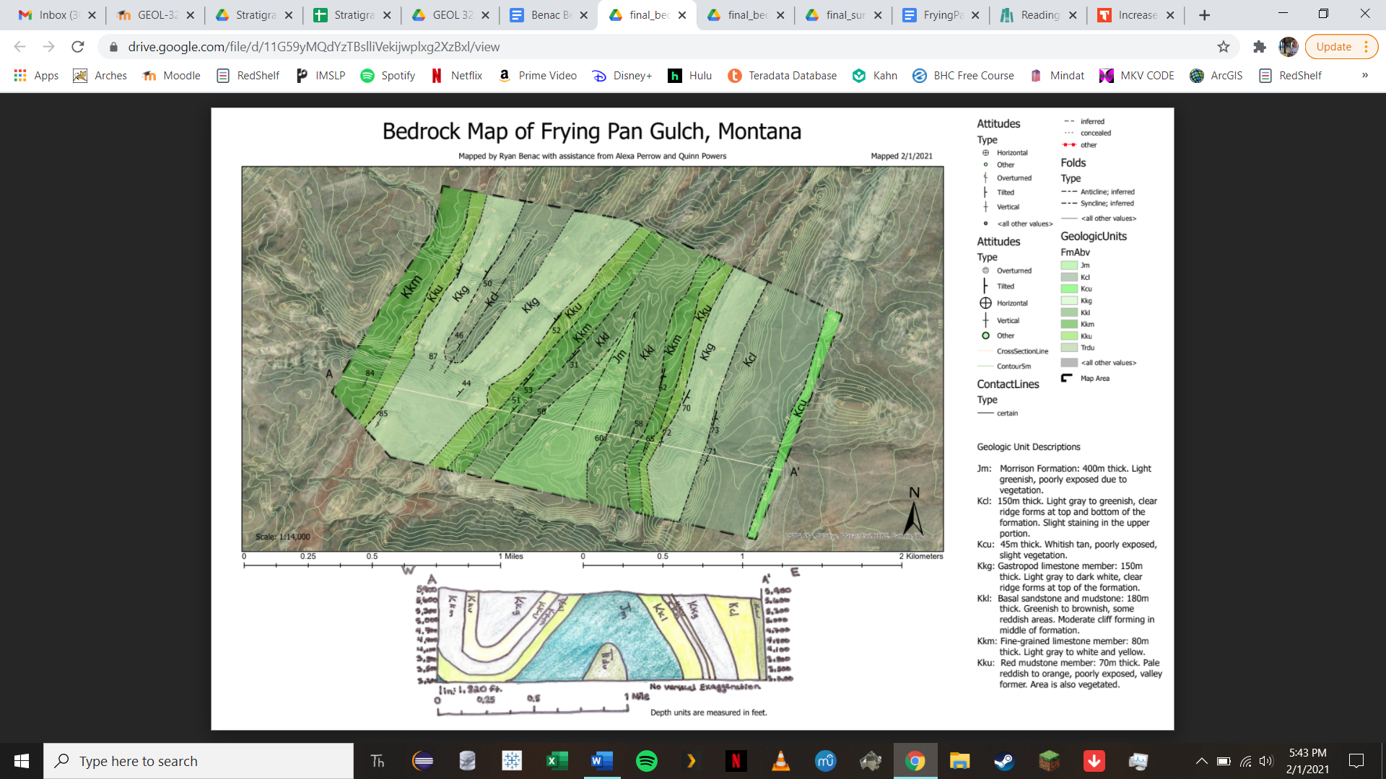

[Figure 2](https://drive.google.com/file/d/12pSD6xKwI95iV5eEOBx3r50Fhi5n9lfg/view?usp=sharing). Surficial Map: Hebgen Lake

Note: A link is attached above for better resolution and downloading.

